**Multi Stage Docker build**

* Multi staged build is used to build the code and copy necessary files into the final stage which will be your image  
  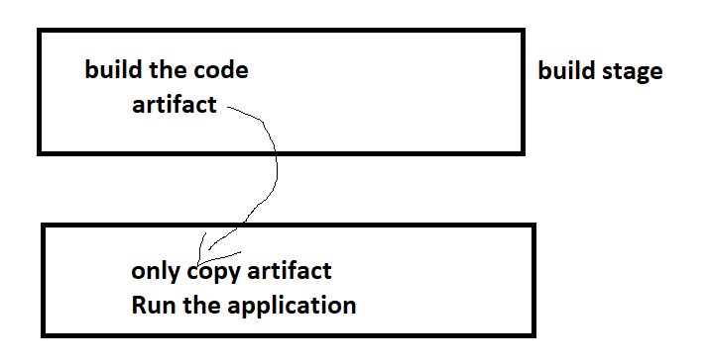
* <https://docs.docker.com/build/building/multi-stage/> for official docs

**Scenario – 1: Java Spring petclinic**

* To build this application we need
  + jdk17
  + maven
  + git
* Manual steps:

git clone https://github.com/spring-projects/spring-petclinic.git

cd spring-petclinic

mvn package

# a file gets created in target/spring-petclinic-*.jar

* To run this application, we need jdk 17
* <https://github.com/asquarezone/DockerZone/commit/968357bc0da234840996e75b3394811715bc35a9> for the changes done to create spring petclinic as multistage build

**Scenario -2 Game of life**

* code <https://github.com/wakaleo/game-of-life>
* tools:
* jdk 8
* git
* maven
* <https://github.com/asquarezone/DockerZone/commit/b16d521e8a8d35471ffa918a7fcd6951f4d7fecd> for the solution

**Pushing images to Registries**

**Docker Hub**

* Public Registry: Docker Hub <https://hub.docker.com/>
* Create a public Repository  
  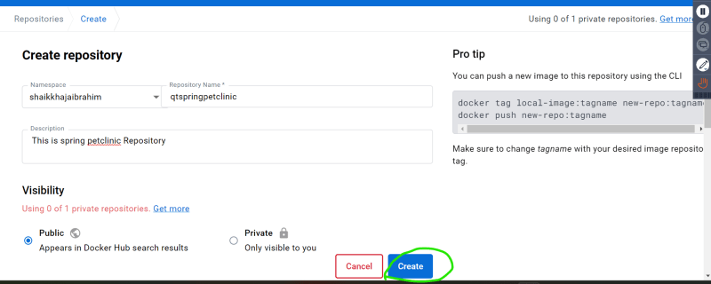
* Repository will be in the form of <username>/<repo-name>:<tag>  
  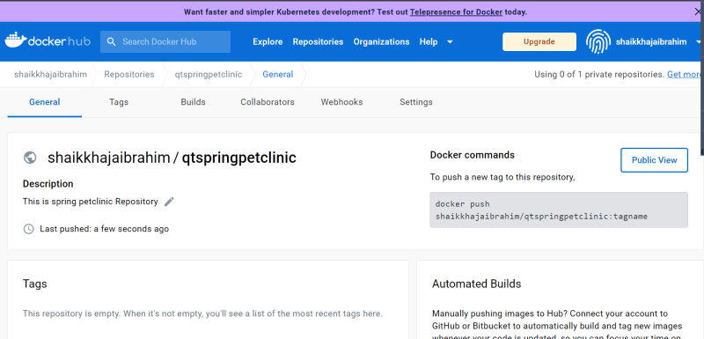
* After building the image tag the image to new naming format

docker image tag spc:3.0.0 shaikhajaibrahim/qtspringpetclinic:3.0.0

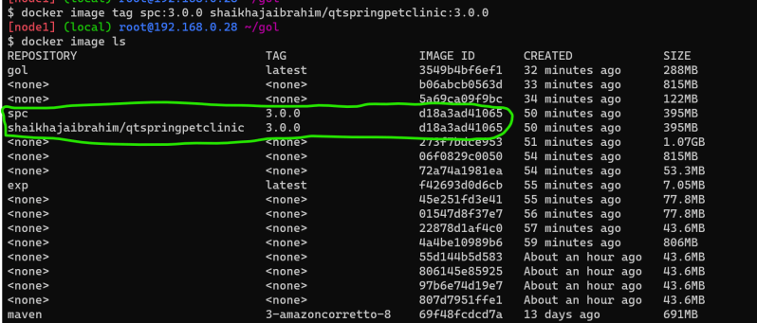  
* if this image has to be default also tag with latest (optional)

docker image tag spc:3.0.0 shaikhajaibrahim/qtspringpetclinic:latest

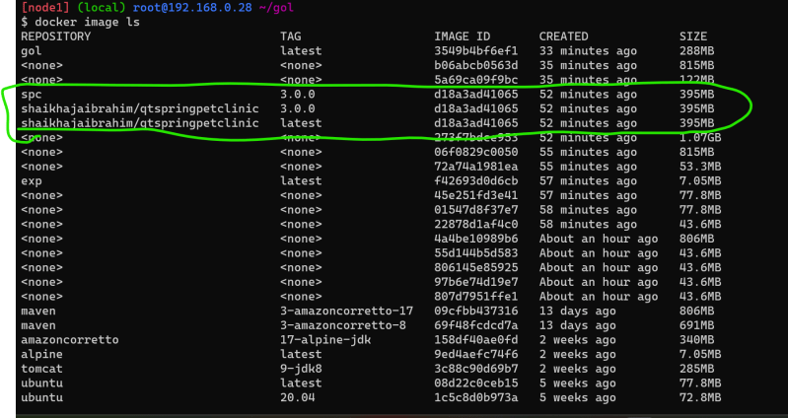  
* login into docker hub from cli

docker login

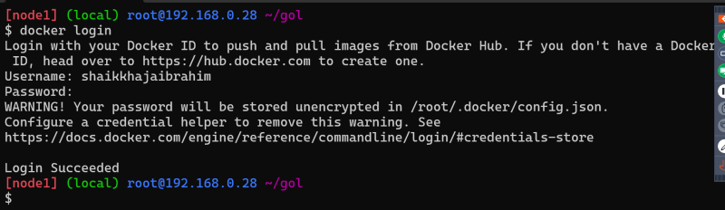  
* lets push the images  
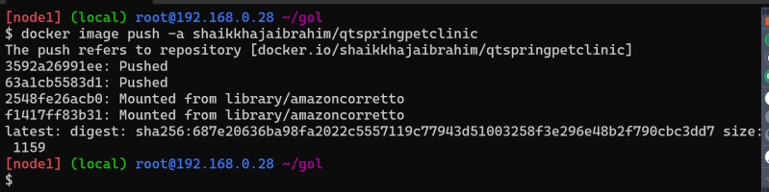  
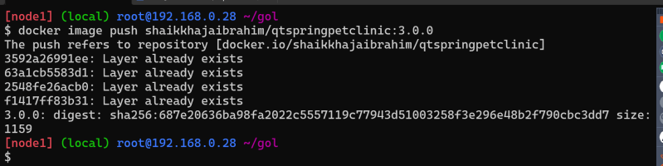  
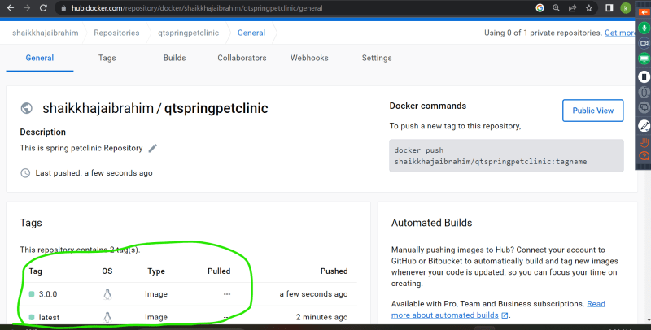

**Private Registries**

* There are many applciations for hosting private registries
  + AWS: ECR (Elastic container registry)
  + Azure: ACR (Azure Container Registry)
  + Jfrog

**AWS ECR**

* Create an ECR Repository  
  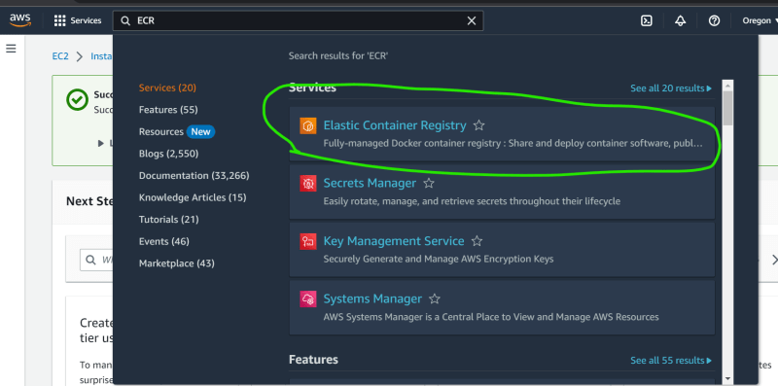  
  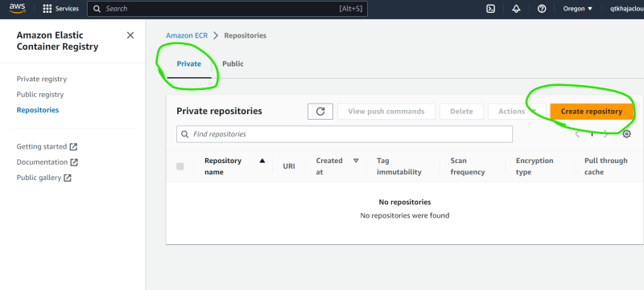  
  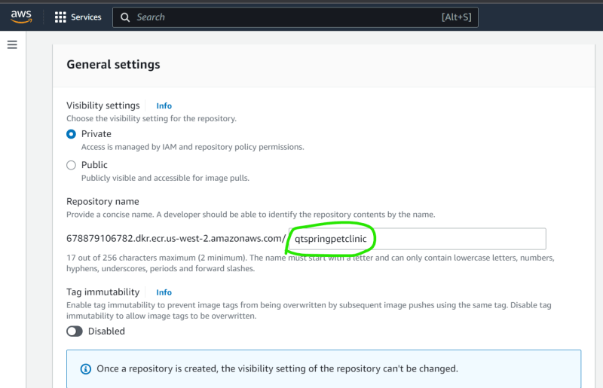  
  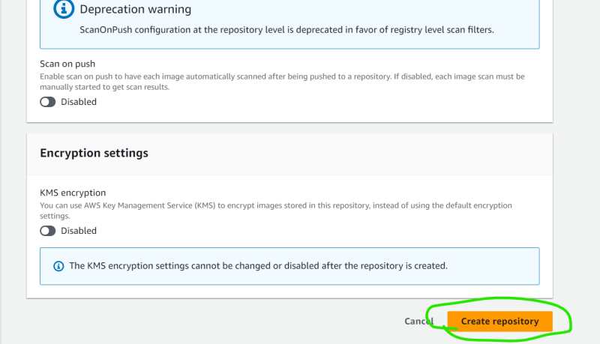
* view push commands  
  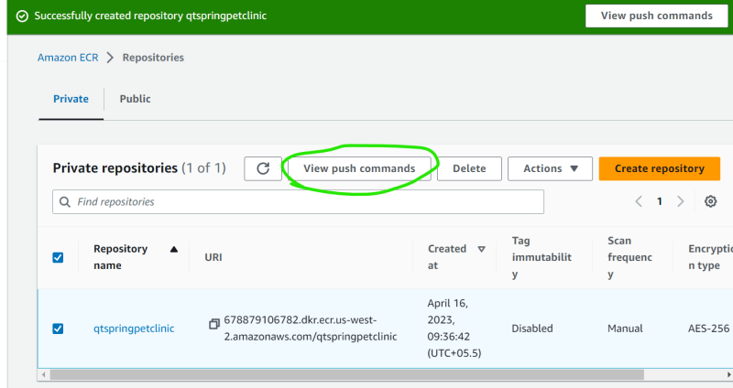
* install and configure aws cli <https://sst.dev/chapters/create-an-iam-user.html>
* follow as shown in class  
  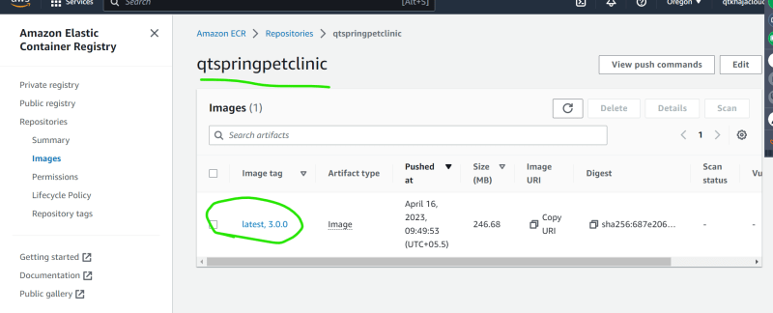

**Azure ACR**

* <https://learn.microsoft.com/en-us/azure/container-instances/container-instances-tutorial-prepare-acr> for detailed information